Stablecoin-Based Settlement
# Source: AI Source: Provided by: [Data Path: Persons Table -> ID Column: 1, Name_En Column: Motasem Essam] -> From: [ChatGPT] on [1/21/2026]
Stablecoin-based settlement refers to using price-stable digital currencies (like USDT or USDC) to settle transactions on blockchains. These stablecoins are typically pegged to fiat currencies (e.g., USD) and offer fast, borderless, and low-volatility settlement for crypto transactions.

🧠 Simple Definition
# Source: AI Source: Provided by: [Data Path: Persons Table -> ID Column: 1, Name_En Column: Motasem Essam] -> From: [ChatGPT] on [1/21/2026]
Stablecoin settlement is when money is transferred using crypto tokens pegged to real-world currency values, enabling fast and predictable settlement on blockchain networks.

💲 Popular Stablecoins Used for Settlement
# Source: AI Source: Provided by: [Data Path: Persons Table -> ID Column: 1, Name_En Column: Motasem Essam] -> From: [ChatGPT] on [1/21/2026]
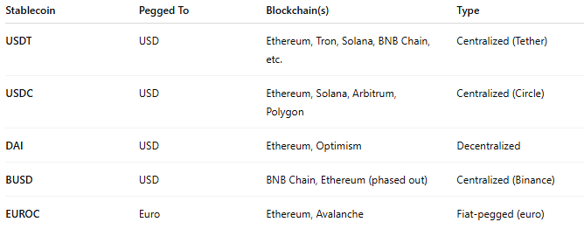

Stablecoin | Pegged To | Blockchain(s) | Type
USDT | USD | Ethereum, Tron, Solana, BNB Chain, etc. | Centralized (Tether)
USDC | USD | Ethereum, Solana, Arbitrum, Polygon | Centralized (Circle)
DAI | USD | Ethereum, Optimism | Decentralized
BUSD | USD | BNB Chain, Ethereum (phased out) | Centralized (Binance)
EUROC | Euro | Ethereum, Avalanche | Fiat-pegged (euro)

⚙️ How Stablecoin Settlement Works
# Source: AI Source: Provided by: [Data Path: Persons Table -> ID Column: 1, Name_En Column: Motasem Essam] -> From: [ChatGPT] on [1/21/2026]
- User initiates a payment (e.g., send 100 USDC).
- Transaction is signed and submitted to a blockchain network (e.g., Ethereum).
- Once confirmed, the recipient gets exactly 100 USDC, which holds stable value (≈ $100).
- No volatility risk or currency conversion is involved in the settlement.

🏦 Use Cases for Stablecoin-Based Settlement
# Source: AI Source: Provided by: [Data Path: Persons Table -> ID Column: 1, Name_En Column: Motasem Essam] -> From: [ChatGPT] on [1/21/2026]
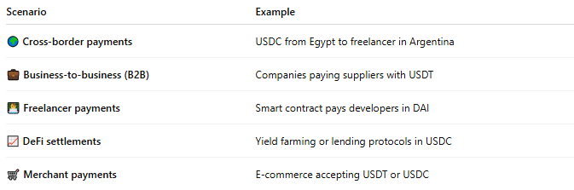

Scenario | Example
🌍 Cross-border payments | USDC from Egypt to freelancer in Argentina
💼 Business-to-business (B2B) | Companies paying suppliers with USDT
👨‍💻 Freelancer payments | Smart contract pays developers in DAI
📈 DeFi settlements | Yield farming or lending protocols in USDC
🛒 Merchant payments | E-commerce accepting USDT or USDC

🧾 Benefits of Stablecoin Settlement
# Source: AI Source: Provided by: [Data Path: Persons Table -> ID Column: 1, Name_En Column: Motasem Essam] -> From: [ChatGPT] on [1/21/2026]
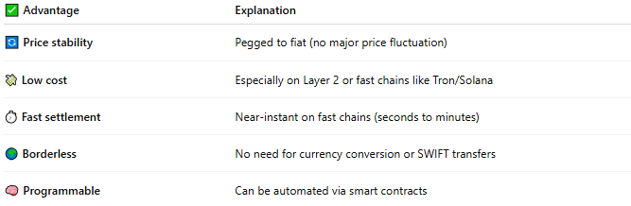

✅ Advantage | Explanation
🔄 Price stability | Pegged to fiat (no major price fluctuation)
💸 Low cost | Especially on Layer 2 or fast chains like Tron/Solana
⏱️ Fast settlement | Near-instant on fast chains (seconds to minutes)
🌍 Borderless | No need for currency conversion or SWIFT transfers
🧠 Programmable | Can be automated via smart contracts

🔐 Risks & Considerations
# Source: AI Source: Provided by: [Data Path: Persons Table -> ID Column: 1, Name_En Column: Motasem Essam] -> From: [ChatGPT] on [1/21/2026]
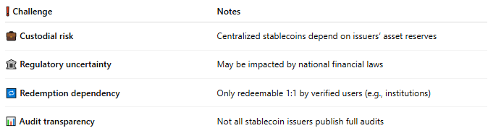

❗ Challenge | Notes
💼 Custodial risk | Centralized stablecoins depend on issuers’ asset reserves
🏛️ Regulatory uncertainty | May be impacted by national financial laws
🔁 Redemption dependency | Only redeemable 1:1 by verified users (e.g., institutions)
📊 Audit transparency | Not all stablecoin issuers publish full audits

📊 Settlement Flow Example: USDC on Ethereum
# Source: AI Source: Provided by: [Data Path: Persons Table -> ID Column: 1, Name_En Column: Motasem Essam] -> From: [ChatGPT] on [1/21/2026]
- Alice sends 250 USDC to Bob on Ethereum.
- The transaction is confirmed in 15–30 seconds.
- Bob receives 250 USDC, redeemable at $1 per token.
- The transfer is final and can be verified on Etherscan.

🧠 Summary
# Source: AI Source: Provided by: [Data Path: Persons Table -> ID Column: 1, Name_En Column: Motasem Essam] -> From: [ChatGPT] on [1/21/2026]
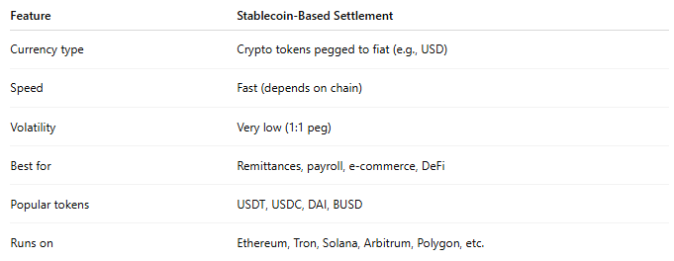

Feature | Stablecoin-Based Settlement
Currency type | Crypto tokens pegged to fiat (e.g., USD)
Speed | Fast (depends on chain)
Volatility | Very low (1:1 peg)
Best for | Remittances, payroll, e-commerce, DeFi
Popular tokens | USDT, USDC, DAI, BUSD
Runs on | Ethereum, Tron, Solana, Arbitrum, Polygon, etc.

